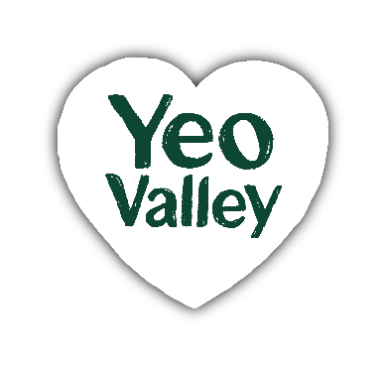  The finer details  Which site am I based at?  Yeo Valley HQ  Which teams am a part of?  YVP Marketing / YVP Exec Team  Who do I report to?  CEO  Who do I look after?  Marketing Team  Team size?  20  Responsibility for a budget?  Yes. Marketing budget  Experience & Skills  Essential:  - Extensive experience in Marketing Leadership and Brand Building.  - A strong track record working on FMCG brands in the UK or other grocery sectors  - Excellent influencer skills, and stakeholder management.  - Excellent at networking and building strong collaborative relationships  - Excellent presentation and communication skills, both verbally and written  - Proven experience building high performing teams  - Strong commercial acumen to drive profitable growth and investment effectiveness |   Marketing Director    Job description  The purpose of your role  Yeo Valley Production has a strong business purpose where we are ambitious to Nurture and Nourish People and Planet. Our business, and our brands, are built on natural, healthy food from the most sustainable farming.  As Marketing Director, you are responsible for developing marketing strategies and implementing long-term plans to help us deliver on our Purpose through the Yeo Valley Organic (“YVO”), Tideford and Ubley brands. You are responsible for leading the activities of the marketing department, defining our opportunities and investment areas, and ensuring great value for our marketing spend. You will have strong commercial acumen, a proven ability to think strategically and creatively, and be an excellent story-teller.  Furthermore, as a member of our Exec Team, you are responsible for shaping the company’s long-term business plans and strategy, as well as being a role-model for engaging and visionary leadership in a purposeful, co-owned business.  Key Responsibilities  Strategic planning: Be responsible for creating and implementing comprehensive marketing strategies that align with the company’s overall business objectives. Identify target markets, setting marketing goals, and determining the best channels to reach consumers.  Brand Strategy: Ensure our ‘house of brands’ remains complementary with clear roles and responsibilities. Use insight generation to assess white spaces for innovation and potentially new brands. Ensure our activities remain distinctive, consistent, and in line with each brand’s values and strategies. Ensure consumers are at the heart of our decision making.  Team Leadership: Lead and manage the marketing team to provide direction, foster collaboration, and ensure that team members are highly engaged and aligned with the marketing strategy, plans and objectives  Insight generation, application and innovation: Define and prioritise the insights needed to achieve business and marketing goals. Apply the right level of judgement in the innovation process to generate great outcomes.  Brand Management: Build and maintain brand awareness and positioning. This includes ensuring brand consistency across all marketing channels and developing promotional strategies that enhance the brands’ images.  Campaign Development and Execution: Oversee the planning, execution, and evaluation of marketing campaigns. This includes coordinating with various departments, such as sales, category, shopper and product, to ensure that campaigns are effective and resonate with the target audience.  Market Research and Analysis: Commission market research to understand consumer behaviour, market trends, and the competitive landscape. Use this data to inform our plans and make data-driven decisions.  Budget Management: You are responsible for the agreed marketing budget and for allocating resources effectively to maximise our return on investment and ensure that marketing initiatives are on time, on budget and effective.  Stakeholder Engagement & Communication: Ensure excellent communication and engagement with stakeholders, including shareholders, the Board, senior management and external partners so that everyone is excited and motivated by the plans. Share the YVO plans with our farmers so that our Yeo Valley farms remain a living embodiment of the YVO brand story.  YVO strategy group & creative partnership:  Work with the Head of YVO brand to ensure the engagement and involvement of the family shareholders in the biggest decisions for the YVO brand via the YVO Strategy Group. Align on brand personality and creative design.  What good looks like for this role  Great strategic thinker and team player at a whole business level. Driven by Purpose and ambitious to make a positive impact in the world.  Demonstrates and role models our leadership principles at all levels of the business. Will strive to gain the buy-in and understanding of others. Excellent communication skills and able to role-model inclusive and collaborative ways of working.  Displays strong leadership skills and expertise within Marketing with strong technical skills across the disciplines of Communications, Insight, Category Innovation and Brand Management.  Proactively nurtures talent, builds capability and provides excellent coaching and line management skills.  Excellent strategic ability and passion for helping consumers and building brands. Strong business acumen and can hold their own in a complex organization and within strong teams of subject matter experts.  Adept at taking complex or ambiguous problems and solving them in a structured and methodical way. Demonstrates a flexible and adaptable approach to embrace change and ambiguity.

HR use

Date of last review: Job reference no: Job level:
Job family:

